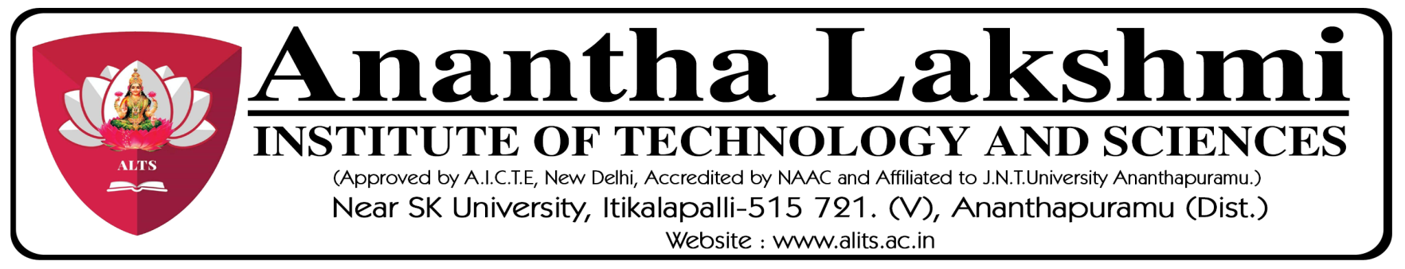
“Rally on Cancer Awareness”
Conducted by Women Development Cell / SHE Cell on 07-11-2023.
The Women Development Cell / SHE Committee of Anantha Lakshmi Institute of Technology and Sciences organized a Rally on cancer awareness on 07-11-2023 in collaboration with NSS unit of ALTs with a total of 150 students from B.Tech, MBA and MCA. The Rally was conducted on occasion of National Cancer Awareness Day. The Rally was started at 11.30 A.M. from Anantha Lakshmi Institute of Technology & Sciences to Ittikalapalli Village with a primary focus on raising awareness about the prevention and early detection of cancer, which stands as the second leading cause of death worldwide. College Management, Principal, Director of Skill Development, Coordinators of Women Development Cell and NSS Unit were participated in the Rally.
Related Photos:
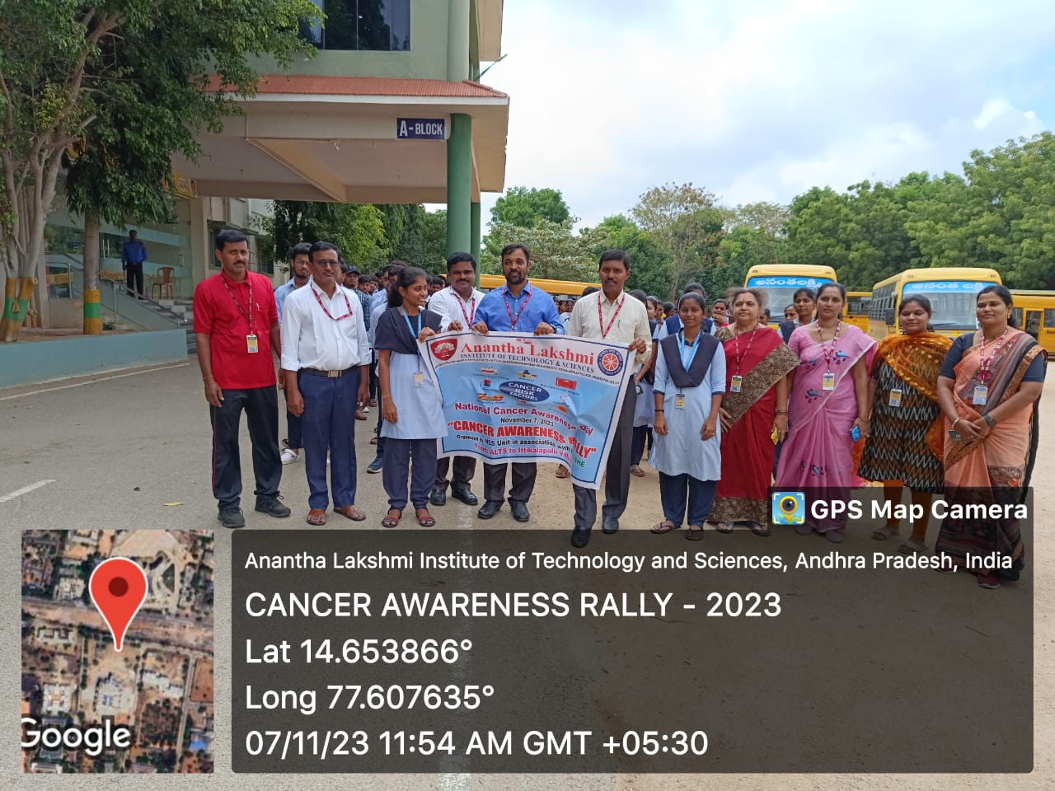
Figure-1: The Rally was flaged off by the Vice Chairman Sri M.Ramesh Naidu garu.
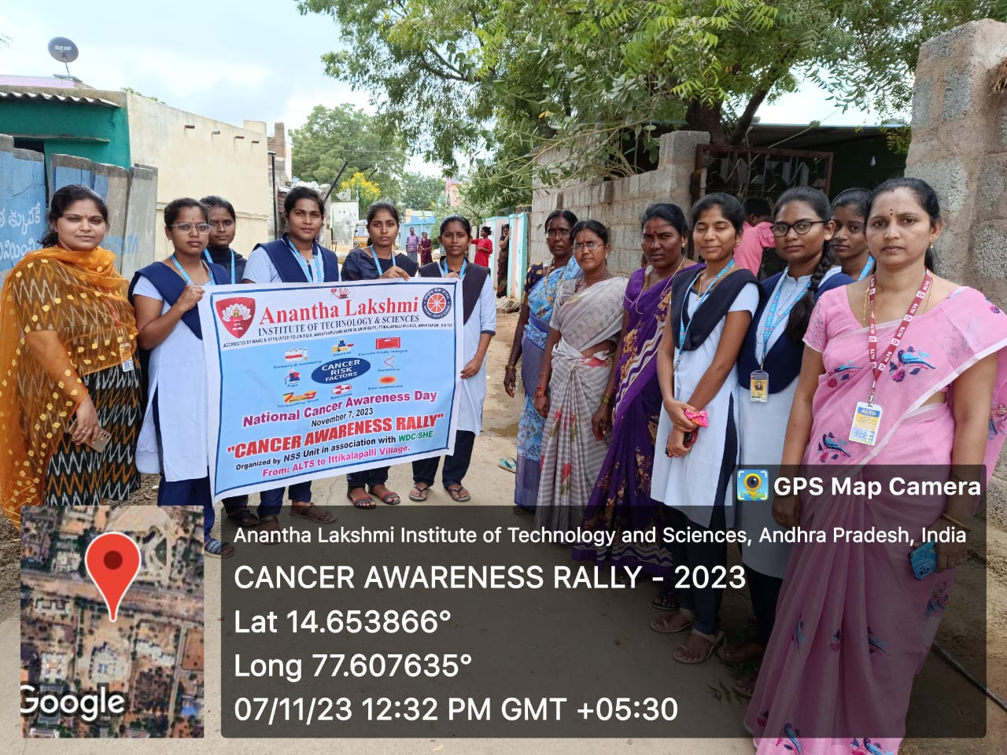
Figure-2:The students explaining the causes for women related cancer for the villagers.
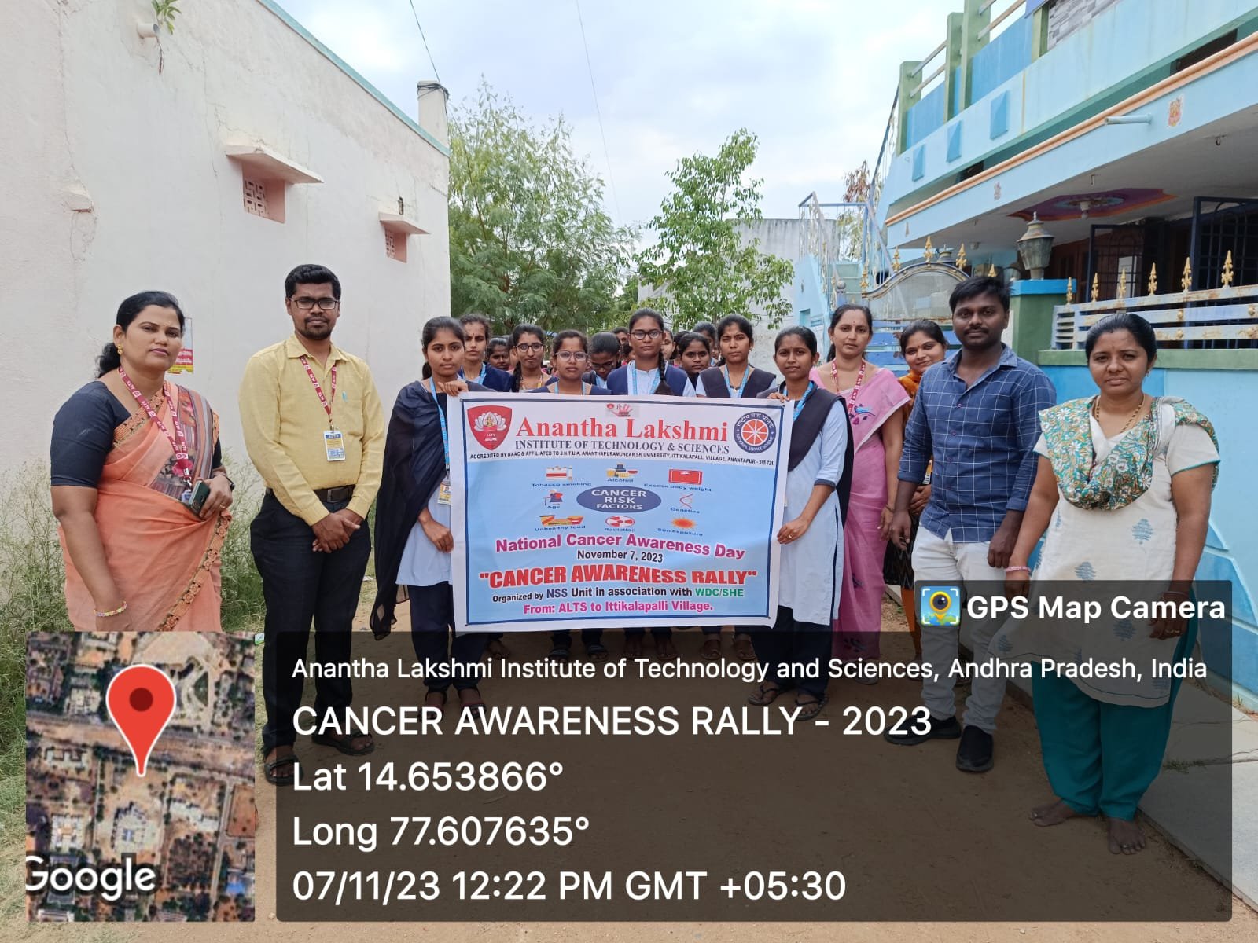
Figure-3: The students and the coordinators of NSS & WDC with the officials of Gram Panchayat.
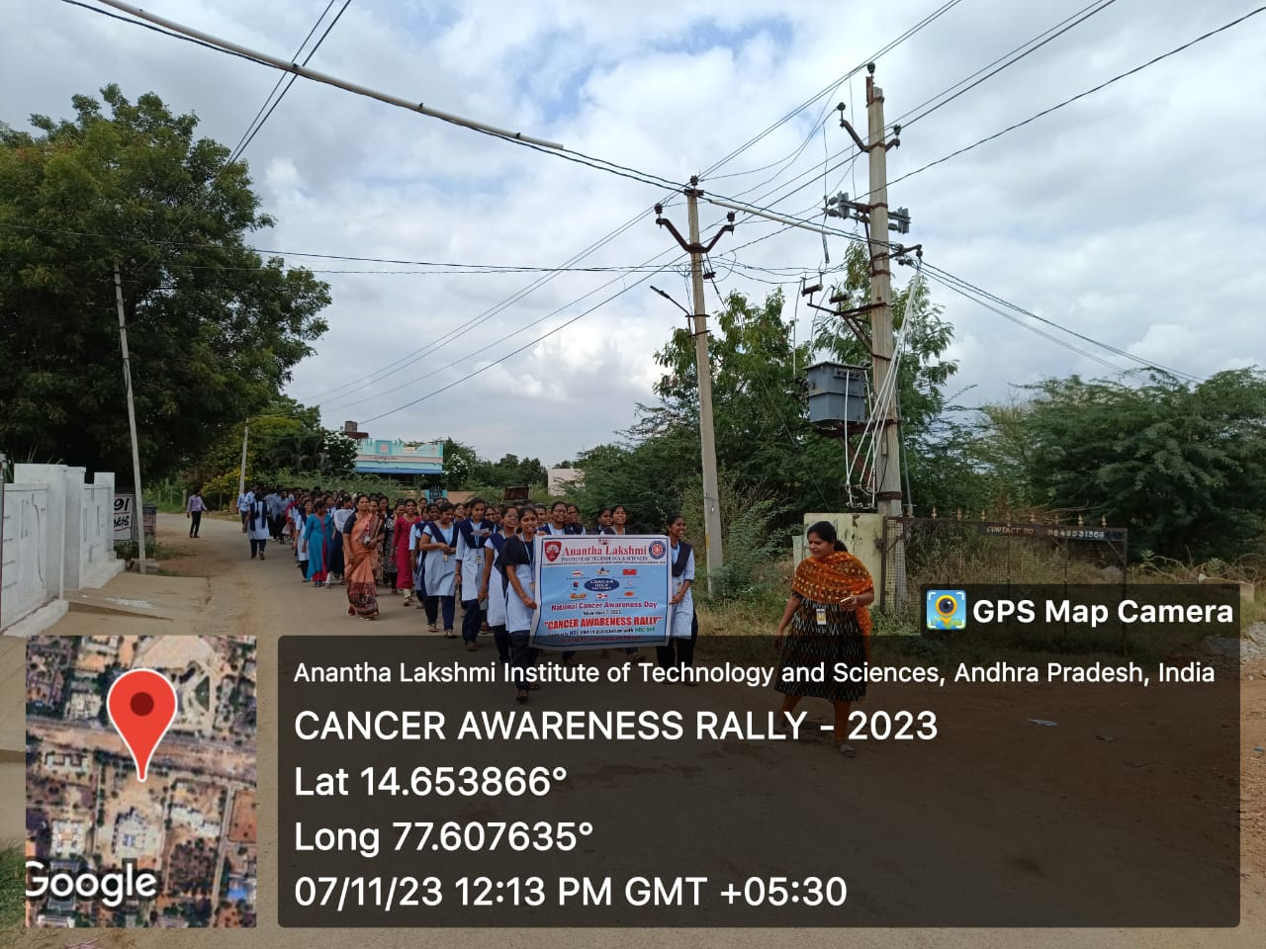
Figure- 4: The students participation in the rally.

